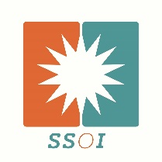
Solar Systems of Indiana, Inc
NABCEP Certified Solar PV Installer #091209-92

www.solarsystemsofindiana.com
e-www.solarindiana@yahoo.com

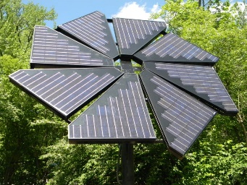

Alex Jarvis is a renewable energy professional since 2006. As a North American Board Certified Energy Practitioner (NABCEP) certified solar PV installer, Alex believes that compliance with the NEC is critical to all installations. He and his company, Solar Systems of Indiana, (www.solarsystemsofindiana.com) have installed or consulted on over 100 renewable energy systems in Indiana alone.

Alex has led over 50 workshops/trainings logging over 1300 hours across the US for the Midwest Renewable Energy Association (MREA), Everblue Training Institute and Clean Edison. Alex instructed at Fort Dix, NJ penitentiary helping give New Jersey fledging solar installers their first Solar trainings. Over

70 of Alex’s former students are currently working in the renewable energy field. As a PV technical advisor for Purdue University, Alex helped guide Purdue's entry to a second place overall finish in the 2011 international Solar Decathlon competition held in Washington DC.

Alex has written about renewable energy for several national publications. Alex is the technical editor of the 2010 Wiley published book, “PV Design and Installation for Dummies” . Alex presented “Residential PV Sales and Finance” at the 2016 Solar Power International, Las Vegas and Chicago.

Alex is a founding member of the grassroots renewable energy advocacy group Southern Indiana Renewable Energy Network (SIREN). His company, Solar Systems of Indiana, Inc. employs three full time designers and installers.

